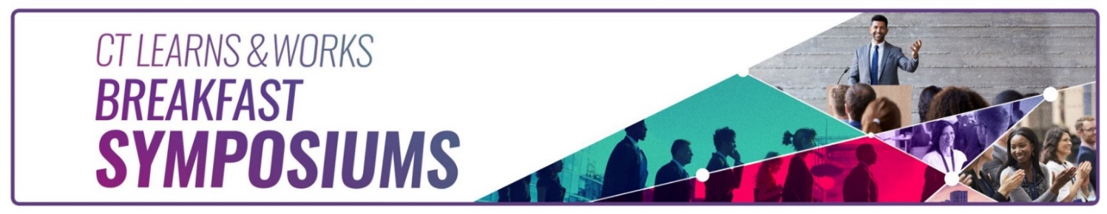
CT Learns and Works – Fall 2024 Breakfast Symposium

CT State Community College Housatonic (Beacon Hall)
900 Lafayette Blvd, Bridgeport, CT 06604

Friday, October 18, 2024

Harnessing AI for Career Development: Opportunities, Risks, and Future Workforce Trends

Agenda

7:30 a.m. Registration and Networking Breakfast

8:15 a.m. Opening and Welcome Remarks
Danté Bartolomeo, Commissioner, CT Department of Labor
Dean, CT State Community College – Housatonic

8:30 – 9:15 a.m. Impact of GenAI in Enhancing Campus Recruitment and Career Success!
Garrison Leykam, SVP of Education Innovation, North America, Assessfy

9:15 -9:30 a.m. Coffee Break

9:30 – 10:00 a.m. Current Labor Market Information
Patrick Flaherty, Research Director, CT DOL Office of Research

10:00 -10:45 a.m. Using AI in Career Development Practice - Possibilities and Pitfalls
Linda Kobylarz, CCSP, FCDI, NCDA Fellow
Caitlin Grant, Honors Program Director at Post University, CCSP candidate

10:45 - 11:00 a.m. Coffee Break

11:00 -11:30 a.m. How to Ethically Use AI for the Job Search Process
Dr. David Ferreira, Provost at Charter Oak State College

11:30 a.m. Closing Remarks

Free registration includes breakfast and a morning of lively discussions and networking. Email ccrn@ct.gov if you have questions.

https://www.eventbrite.com/e/ct-learns-and-works-fall-2024-breakfast-symposium-tickets-1003894915717

